What kind of roles will you find at Geoscience Australia?
Here you’ll find a wide range of scientific, professional, and technical roles including career development
and mobility opportunities, and opportunities to grow your management experience.
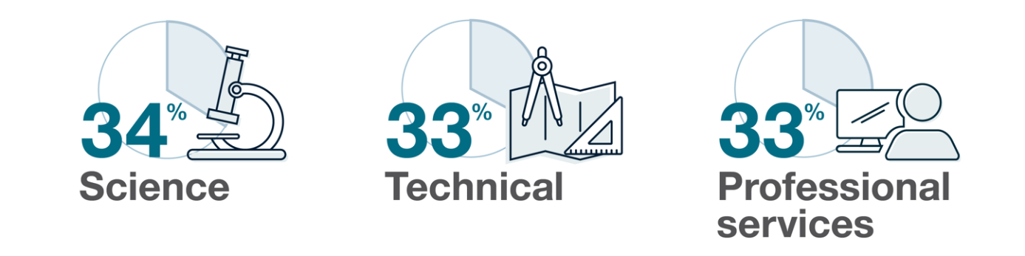
Our people bring interpersonal and leadership skills to all they do, regardless of their level. They are collaborators who work across the organisation and with external stakeholders to deliver interdisciplinary excellence. Our people harness diversity and deliver sustainable high-quality results by contributing to a culture of physical and psychological safety whether they’re in working in Canberra, Dongara, or Papua New Guinea.
We look for scientists with skills and experience in fields such as:

- Geosciences
- Geophysics
- Geospatial
- Earth Observation
- Geology
- Environmental science
- Engineering
- Palaeontologists
- Archaeologists
- Anthropologists (Cultural Heritage)
- Future Technologists

We look for people with professional services skills and experience in areas such as:

- Accounting
- Administration
- Audit
- Communications and marketing
- Compliance
- Finance Intelligence
- Human Resources
- Legal and Parliamentary
- Policy
- Portfolio, program, and project management
- Service Delivery

We look for people with technical skills and experience in areas such as:

- Data and Research
- Electrical technicians
- Engineering
- Fabrication
- Information Communications Technology
- Information and knowledge management
- Machinists

While much of our work takes place at our Canberra location in Symonston, we also have offices in Alice Springs (NT) and near Dongara (WA). Our people may travel to these and other rural and remote areas, including internationally, to undertake field work or for scientific engagement.
Find an opportunity: current vacancies
To speak to a staff member about work with us contact HR@ga.gov.au
Go back to Why work with us

